CURRICULUM VITAE

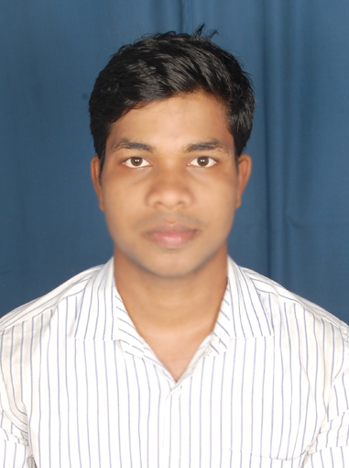
Jitendra kumar samantaray
Email- jitendrasamantaray143@gmail.com
Phone- 9776401514

Profile - A Challenging determined Graduate (B.Tech) in Computer Science with good communication skills and ready to work both independently and as a member of a team, utilizing the skills acquired during my course and experience.Willing to work as a key player in challenging & Creative environment.

Career Objective - A career in Software Engineering and Designing position that provides opportunities for personal and professional development as well as contributes to organizations effectiveness in order to take the company to the top position wherever I work.
Academic Qualification:-

Course | Board/University | Institution | CGPA
B.Tech | BPUT,ROURKELA(2011) | TEMPLCITY INSTITUTE OF TECHNOLOGY AND ENGINEERING,BHUBANESWAR | 68%
Course | Board/University | Institution | % of Marks | Year of passing
12th | CHSE | CHOUDAMOUZA BIDYUT MOHAV.,GARASANAPUT | 51% | 2007
10th | HSC | BAUNSAGARH HIGH SCHOOL,BAUNSAGARH | 72% | 2005

Achievements:-

- Had District level champion in KABADI.

Technical Details –

Programming Language - C, C++, .NET,HTML,
Database - DBMS
Web Technology - HTML
Operating System - WINDOWS 7

PROJECT:-

Project Name : Hospitality Management
Team size : 5
Environment : .NET,SQL SERVER,HTML.
Duration : Completed

Personal Traits: Goal Oriented, Dynamic and Hard Working, Good in team work
Good in inter personal relationship and communications.
Hobbies: Playing Cricket, Watching Movies, Surfing Websites,
Listening Slow Music and Sometimes get updated to Newspapers.

Personal Profile -

Date of birth : 23rd April,1989
Gender : Male
Marital status : Single
Phone : 09178202586/9776401514
Fathers name : Laxmidhar Samantaray
Languages : English, Hindi, Oriya.
Nationality : Indian
Address : Jitendra kumar samantaray
C/O-Laxmidhar samantaray
AT/PO- Baunsagarh
DIST- Nayagarh
VIA- Raj ranpur,Odisha,India

Declaration:-
`
I consider myself familiar with Computer Science Engineering Aspects. I am also confident of my ability to work in a team.

I hereby declare that the information furnished above is true to the best of my knowledge.

Date:

Place: Bhubaneswar Jitendra kumar samantaray

